DBMS Project Report

PES University

Database Management Systems

UE18CS252

Submitted By

|  |  |  |
| --- | --- | --- |
| **SRN :**  **PES1201800152** | **Name** :  **ROHIT VISHWAKARMA** | **Evaluation date and time:**  **Date : 23 - 05 - 2020**  **Time - 10 : 00 am** |

**Functional Dependencies**

**2**

**Identifying Keys based on FDs 2**

**Normalization** **& testing for lossless join property 2+2**

**DDL****: Table creation with all constraints 2+2**

**Triggers** **2**

**SQL Queries** **2**

**Viva / modifications (Unit III/ IV concepts) 2+2**

**Taxi Service Database**

|  |
| --- |
| **Problem statement:**  Suppose that you want to start a taxi service in your city or nearby regions . Design a database for the taxi service where you as a owner of the taxi service can decide what  variety of cabs you want to keep (Ex . Mini, micro, sedan, etc) and also you can set their  cost per Km in (₹) . You should be able to allot cabs of the above mentioned types in the  database along with the number of cabs of each type . You should store the recruited drivers in the database along with the salary and cab_id which they ride . Your database  should give the option to delete the cab type(Ex. Mini , micro, sedan etc) and also the associated cabs of that type . There should be an option to convert or upgrade a cab type  ie.(You could change all the mini cabs to micro etc.). Coming to the relations the db must have a Relation for the drivers with details like (phone, cab number they drive , cab_type,salary ,experience ) , client relation with (client_id, fname,lname , e-wallet id , phone number city) and a wallet relation with (wallet id , balance ), ride relation with  client id, driver_id and cab , pickup and drop location , ride status (D’ for done completed , ‘C’ for confirmed to arrived‘) ride fare (only e-wallet so every client must maintain a wallet). This db should be have the following constraints that no drivers have the difference between age and experience (age – experience > 20 yrs ), no two  clients have same phone number and no two drivers can have same phone numbers.  There should be a trigger that automatically check the e-wallet balance and let the transaction happen if the ride fare is less or equal to current balance otherwise should return None. There must be views in the database which display the ride duration of each driver from the joining . There facilities for the client to add money in the e -wallet , check there past rides . This db should have relation for the revenue from each of the cab type  and also the overall revenue .  1. Have a console based front end  2. Backend Postgres 11 |

**click on the below link for source code**

[**https://github.com/ROHIT25082000/Destination-Travels**](https://github.com/ROHIT25082000/Destination-Travels)

# **Database Schema: (show all the tables and the constraints)**

Below this I leave the screenshots of the generated tables from the DBMS postgres shell

**1.) List of all relations in the Db**

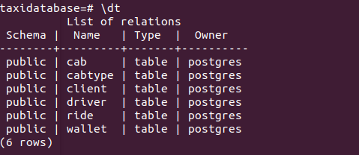

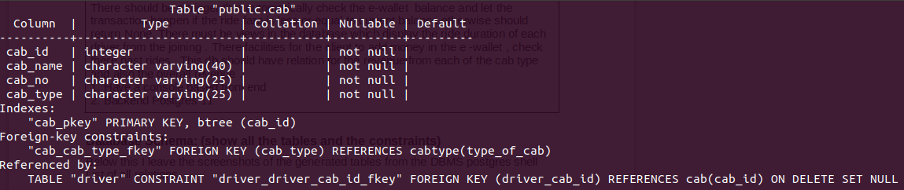 **2.) cab(cab_id , cab_name, cab_no, cab_type)**

**3.) cabtype(type_of_cab , charge_perkm)**

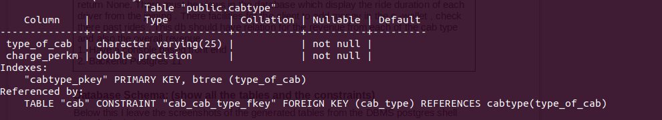

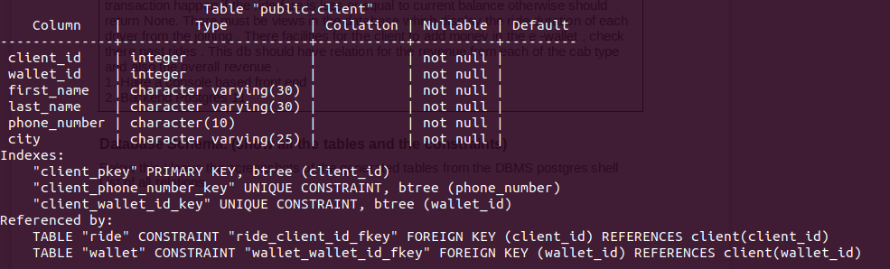 **4.)client(client_id ,wallet_id ,first_name,last_name,phone_number)**

# **5.) driver(driver_id, first_name,last_name,salary,experience , age,phone_number,driver_cab_id)**

# 

# **6.) ride( client_id , driver_id , ride_start_time, ride_end_time , source , destination , ride_status , ride_fare , ride_otp )**

# 

# **7.) wallet (wallet_id , balance)**

# 

# **Functional Dependencies: (List based on your application constraints)**

1.) *Functional Dependencies in the relation*

*client( Client_id , first_name , last_name , wallet_id, phone_number, city)*

***(i) client_id →first_name , last_name , wallet_id , phone_number , city***

**(ii) wallet_id → client_id , first_name , last_name , phone_number , city**

2.) *Functional Dependencies in the relation*

*cab(cab_id , cab_name, cab_no,cab_type, charge_perKm)*

***The above relation was normalized***

**(i) cab_id → cab_name , cab_no, cab_type , charge_perKm**

**(ii) cab_name, cab_no → (cab_type , cab_id)**

**(iii) cab_type → charge_perKm**

*3.) Functional Dependencies in the relation*

*driver(driver_id , first_name , last_name , salary , experience ,age,phone_number , driver_cab_id)*

**(i) driver_id → (driver_id , first_name , last_name , salary , experience , age,phone_number, driver_cab_id)**

*4.) Functional Dependencies in the relation*

wallet(wallet_id , balance)

**(i) wallet_id → balance**

5.) Functional Dependencies in the relation

*ride( client_id , driver_id , ride_start_time, ride_end_time , source , destination , ride_status , ride_fare , ride_otp )*

**(i) client_id , driver_id , ride_start_time, ride_end_time → source , destination , ride_status , ride_fare , ride_otp)**

# **Candidate keys: (Justify how did you get these as keys)**

**1.)  *client( Client_id , first_name , last_name , wallet_id, phone_number, city)***

In this relation we have the functional dependencies

***(i) client_id →first_name , last_name , wallet_id , phone_number , city***

**(ii) wallet_id → client_id , first_name , last_name , phone_number , city**

**Candidate keys : client_id , wallet_id**

**Clearly Attribute closure of (client_id)+ and (wallet_id)+  = Total relation “client”**

**So it is a super key and also is the minimal hence they are the candidate keys.**

**I have choosen “client_id” as the primary key of the available candidate keys.**

**2.)**

***driver(driver_id ,first_name ,last_name ,salary ,experience ,age,phone_number ,driver_cab_id)***

In this relation we have the functional dependencies

**(i) driver_id → (driver_id , first_name , last_name , salary , experience , age,phone_number ,driver_cab_id)**

**Candidate key : driver_id**

**Clearly Attribute closure of (driver_id)+  = Total relation “driver”**

**So it is a super key and also is the minimal hence it is the candidate keys.**

**I have choosen “client_id” as the primary key of the available candidate keys.**

**3.)**

***ride( client_id , driver_id , ride_start_time, ride_end_time , source , destination , ride_status , ride_fare , ride_otp )***

In this relation we have the functional dependencies

***(i)(c*lient_id , driver_id , ride_start_time, ride_end_time) → source ,destination , ride_status , ride_fare , ride_otp**

**Candidate key : (*c*lient_id , driver_id , ride_start_time, ride_end_time)**

**This is because in the ride table attribute closure of**

**(*c*lient_id , driver_id , ride_start_time, ride_end_time)+ = Relation (ride)**

**and dropping any of the attributes of the above makes it lose the closure of the**

**whole relation and then it is not possible to find a unique a tuple in the ride.**

***4.)* wallet(wallet_id , balance)**

**(i) wallet_id → balance**

**Candidate key : wallet_id**

**As (wallet_id)+ = relation wallet and it also minimal so candidate key is wallet_id .**

**5.)***Functional Dependencies in the relation*

*cab(cab_id , cab_name, cab_no,cab_type, charge_perKm)*

**(i) cab_id → cab_name , cab_no, cab_type , charge_perKm**

**(ii) cab_name, cab_no → (cab_type , cab_id)**

**(iii) cab_type → charge_perKm**

***Candidate keys : (cab_id) , (cab_name, cab_no)***

**This is because in the ride table attribute closure of**

**(*cab*_id)+ , (cab_name ,cab_no) + = Relation (ride) and lossing any one is**

**makes it not key.**

# **Normalization and testing for lossless join property:**

# **According to the above discussion on functional dependencies and candidate keys for the relations**

1.) *Functional Dependencies in the relation*

*client( Client_id , first_name , last_name , wallet_id, phone_number, city)*

***(i) client_id →first_name , last_name , wallet_id , phone_number , city***

**(ii) wallet_id → client_id , first_name , last_name , phone_number , city**

**Candidate keys are : client_id, wallet_id**

**Since all the functional dependencies f(A) → B in Client have A as candidate key which is in turn is a super key hence is it is in BCNF and hence in 3NF**

**also**

**Result : Client relation is normalized in BCNF, 3NF**

2.) *Functional Dependencies in the relation*

*driver(driver_id , first_name , last_name , salary , experience ,age, driver_cab_id)*

**(i) driver_id → (driver_id , first_name , last_name , salary , experience , age,phone_number, driver_cab_id)**

**Candidate key : driver_id**

**Since all the functional dependencies in the relation f(A) → B have their**

**determinant as a SuperKey *(every candidate key is a super key)* so this**

**driver relation is also in BCNF , 3NF .**

**Result : Driver relation is normalized in BCNF, 3NF**

**3.)** *Functional Dependencies in the relation*

*wallet(wallet_id , balance)*

**(i) wallet_id → balance**

***Candidate key : wallet_id***

**Since all the functional dependencies in the relation f(A) → B have their**

**determinant as a SuperKey *(every candidate key is a super key)* so this**

**driver relation is also in BCNF , 3NF .**

**Result : Wallet relation is normalized in BCNF, 3NF**

**4.)***Functional Dependencies in the relation*

*cab(cab_id , cab_name, cab_no,cab_type, charge_perKm)*

**(i) cab_id → cab_name , cab_no, cab_type , charge_perKm**

**(ii) cab_name, cab_no → (cab_type , cab_id)**

**(iii) cab_type → charge_perKm**

***Candidate keys : (cab_id) , (cab_name, cab_no)***

***Therefore***

***prime attributes : cab_id , cab_name, cab_no***

***non prime attributes : cab_type, charge_perKm***

**In the functional dependencies (iii) cab_type is not a super key hence it is not in BCNF.**

**Lets see the 3 NF condition**

**We have in functional dependencies (i)and (ii) determinant ( A) as super key**

**but there is a functional dependency from (Non prime ) to (Non prime)**

**we call this is as transitive dependency and thus is not in 3NF**

**So this relation has to be normalized**

***cab(cab_id , cab_name, cab_no,cab_type, charge_perKm)***

**Cab(cab_id, cab_name ,cab_no,cabtype) Cabtype(cabtype,charge_perKm)**

**So now both are in BCNF as Cab has only superkey as fd : (cab_id)+  = relation Cab and even Cabtype is in BCNF as only superkey as fd : (cabtype)+= retation**

# **Now we can verify that**

**attr(Cab) U att(Cabtype) = attr(Original_relation)**

**attr(Cab) ꓵ att(Cabtype) != attr(Original_relation)**

**and attr (cabtype) is superkey in Cabtype relation so this**

**proves that this decomposition is lossless**

# **5.) *ride( client_id , driver_id , ride_start_time, ride_end_time , source , destination , ride_status , ride_fare , ride_otp )***

In this relation we have the functional dependencies

***(i)(c*lient_id , driver_id , ride_start_time, ride_end_time) → source ,destination , ride_status , ride_fare , ride_otp**

**Candidate key : (*c*lient_id , driver_id , ride_start_time, ride_end_time)**

**Only one functional dependencies is have superkey as the determinant so in**

**BCNF , 3NF**

**Result : ride is Normalized in BCNF , 3NF .**

# **DDL**

# **The below are the DDL for the database they run in a python file named schema.py using psycopg2 adapter .**

Sql = """

CREATE TABLE client(

client_id int primary key,

wallet_id int unique not null,

first_name VARCHAR(30) not null,

last_name VARCHAR(30) not null,

phone_number CHAR(10) unique not null,

city VARCHAR(25) not null

)

"""

cursor.execute(sql)

sql = """

CREATE TABLE cabtype(

type_of_cab VARCHAR(25) primary key,

charge_perKm FLOAT not null

)

"""

cursor.execute(sql)

sql = """

CREATE TABLE cab(

cab_id int primary key,

cab_name VARCHAR(40) not null,

cab_no VARCHAR(25) not null,

cab_type VARCHAR(25) not null references cabtype(type_of_cab)

)

"""

cursor.execute(sql)

sql = """

CREATE TABLE driver(

driver_id int primary key,

first_name VARCHAR(30) not null,

last_name VARCHAR(30) not null,

salary FLOAT not null,

experience int not null,

age int not null check (age - experience >= 20),

phone_number CHAR(10) unique not null,

driver_cab_id int references cab(cab_id) on delete set null)"""

cursor.execute(sql)

sql = """

CREATE TABLE wallet(

wallet_id int not null references client(wallet_id),

balance float not null

); ”””

cursor.execute(sql)

sql = """

CREATE TABLE ride(

client_id int not null references client(client_id),

driver_id int not null references driver(driver_id),

ride_start_time timestamp not null,

ride_end_time timestamp not null,

source VARCHAR(300) not null,

destination VARCHAR(300) not null,

ride_status char not null,

ride_fare float not null,

ride_otp int not null,

PRIMARY KEY(client_id,driver_id,ride_start_time,ride_end_time)

)

"""

cursor.execute(sql)

# **Triggers:**

In my database application when the client tries to update or a new row is inserted into the

***wallet***relation then a trigger will check **BEFORE inserting or updating** whether the

**new.balance < 0 if it is then the trigger returns Null else returns the new.balance**

**The following is the stored procedure and the trigger in the sql .**

sql_trigger = """

create or replace function tell_about_wallet()

returns trigger language plpgsql as $$

begin

return case

when new.balance < 0 then null

else new

end;

end $$;

"""

cursor.execute(sql_trigger)

sql = """

create trigger tell_about_wallet

before insert or update on wallet

for each row execute procedure tell_about_wallet();

"""

cursor.execute(sql)

# **Views:**

# According to the problem statement the cab service owner also needs a view to get the ride duration of all the drivers in the company called “ driver_working_hours ”

View Description

This view in the sql returns the driver details and the sum of the hours they have worked till now in the descending order

sql_view = """

CREATE VIEW driver_working_hours as

select

driver_id ,first_name||' '||last_name as Fullname ,age,phone_number, cab_type ,total_ride_time

from

cab join driver on cab.cab_id = driver.driver_cab_id natural join

(select driver_id ,SUM((cast(ride_end_time as date) - cast(ride_start_time as date))*24) as total_ride_time

from ride natural join driver

group by driver_id)

as t

order by total_ride_time

DESC;

"""

cursor.execute(sql_view)

# **SQL Queries:**

# **Insertions into relation takes place by various python classes which have the**

# **Sql query in the bold .**

# **1.) Insertion Queries .**

**Insertion into the client relation**

class Client:

#fp = open("meta.dat","r")

#mystr = fp.read().split(',')

CLIENT_ID = None#int(mystr[0])

WALLET_ID = None#int(mystr[1])

mystr = None # List

#fp.close()

def __init__(self,first_name,last_name,phone,city,balance):

Client.set_class_var_client() # set them

self.client_id = Client.CLIENT_ID

self.wallet_id = Client.WALLET_ID

self.first_name = first_name

self.last_name = last_name

self.phone = phone

self.city = city

**sql = """**

**INSERT INTO client(client_id,wallet_id,first_name,last_name,phone_number,city)**

**VALUES ("""+str(self.client_id)+","+str(self.wallet_id)+","+"\'"+str(self.first_name)+"\'"+","+"\'"+str(self.last_name)+"\'"+","+"\'"+str(self.phone)+"\'"+","+"\'"+str(self.city)+"\'"+")"**

**cursor.execute(sql)**

obj = Wallet(Client.WALLET_ID,balance)

Client.increment_number_of_client()

Client.change()

**Insertion into the Cabtype relation**

class Cabtype:

cabtype_num = 0

def __init__(self,type_of_cab,cost_per_km):

self.type_of_cab = type_of_cab

self.cost_per_km = cost_per_km

**sql = """**

**INSERT INTO cabtype(type_of_cab,charge_perKm)**

**VALUES ("""+"\'"+str(self.type_of_cab)+"\'"+","+"\'"+str(self.cost_per_km)+"\'"+")"**

**cursor.execute(sql)**

Cabtype.increment_number_of_cabtype()

**Insertion into Cab relation**

class Cab:

#fp = open("meta.dat","r")

mystr = None#fp.read().split(',')

CAB_ID =None# int(mystr[2])

#fp.close()

def __init__(self,cab_name,cab_no,cab_type):

Cab.set_class_var_cab() #set them

self.cab_id = Cab.CAB_ID # auto generated

self.cab_name = cab_name

self.cab_no = cab_no

self.cab_type = cab_type

**sql = """**

**INSERT INTO cab(cab_id,cab_name,cab_no,cab_type)**

**VALUES ("""+"\'"+str(self.cab_id)+"\'"+","+"\'"+str(self.cab_name)+"\'"+","+"\'"+str(self.cab_no)+"\'"+","+"\'"+self.cab_type+"\'"+")"**

**cursor.execute(sql)**

Cab.increment_number_of_cabs()

**Insertion into driver**

class Driver:

#fp = open("meta.dat","r")

mystr = None #fp.read().split(',')

DRIVER_ID = None # int(mystr[3])

#fp.close()

def __init__(self,first_name,last_name,salary,experience,age,phone_number,driver_cab_id):

Driver.set_class_var_driver()

self.driver_id = Driver.DRIVER_ID

self.first_name = first_name

self.last_name = last_name

self.salary = salary

self.experience = experience

self.age = age

self.phone_number = phone_number

self.driver_cab_id = driver_cab_id

**sql = """**

**INSERT INTO driver(driver_id,first_name,last_name,salary,experience,age,phone_number,driver_cab_id)**

**VALUES ("""+"\'"+str(self.driver_id)+"\'"+","+"\'"+self.first_name+"\'"+","+"\'"+self.last_name+"\'"+","+"\'"+str(self.salary)+"\'"+","+"\'"+str(self.experience)+"\'"+","+"\'"+str(self.age)+"\'"+","+"\'"+str(phone_number)+"\'"+","+"\'"+str(self.driver_cab_id)+"\'"+")"**

**cursor.execute(sql)**

Driver.increment_number_of_driver()

**Insertion in ride and wallet query**

class Ride:

number_of_rides = 0

def __init__(self, client_id, driver_id, ride_start_time, ride_end_time, source, destination, ride_status, ride_fare, ride_otp):

self.client_id = client_id

self.driver_id = driver_id

self.ride_start_time = ride_start_time

self.ride_end_time = ride_end_time

self.source = source

self.destination = destination

self.ride_status = ride_status

self.ride_fare = ride_fare

self.ride_otp = ride_otp

**sql = """**

**INSERT INTO ride(client_id, driver_id, ride_start_time, ride_end_time, source, destination, ride_status, ride_fare, ride_otp)**

**VALUES ("""+"\'"+str(self.client_id)+"\'"+","+"\'"+str(self.driver_id)+"\'"+","+"\'"+str(self.ride_start_time)+"\'"+","+"\'"+str(self.ride_end_time)+"\'"+","+"\'"+str(self.source)+"\'"+","+"\'"+str(self.destination)+"\'"+","+"\'"+str(self.ride_status)+"\'"+","+"\'"+str(self.ride_fare)+"\'"+","+"\'"+str(self.ride_otp)+"\'"+")"**

**cursor.execute(sql)**

class Wallet:

number_of_wallets = 0

def __init__(self,wallet_id,balance = 0):

self.wallet_id = wallet_id

self.balance = balance

**sql = """**

**INSERT INTO wallet(wallet_id,balance)**

**VALUES ("""+"\'"+str(self.wallet_id)+"\'"+","+"\'"+str(self.balance)+"\'"+")"**

**cursor.execute(sql)**

**Wallet.increase()**

**Some retrieval querires**

**1.) *A query to check the current wallet balance and returns the balance***

**sql = """**

**Select balance from client natural join**

**wallet where client_id = """+str(current_obj.client_id)**

**cursor.execute(sql)**

**balance = cursor.fetchall()**

**2.) *A query which checks the vacancy for the drivers returns the number of vacant posts***

**sql = """**

**select count(*) from (**

**select cab_id**

**from cab**

**except**

**select driver_cab_id**

**from driver) as t**

**"""**

**cursor.execute(sql)**

**vacancy = cursor.fetchall()**

**3.) *A query which return the data by using a View defined earlier “driver_working_hours”***

**sql = "SELECT * FROM driver_working_hours "**

**cursor.execute(sql)**

**rows = cursor.fetchall()**

***4.)A query to get the revenue per cabtype of the cabs who have completed the ride and have ride status = ‘D’ which means completed***

**sql = """**

**select cab_type , sum(ride_fare) as Total_revenue_generated**

**from ride natural join driver join cab on driver.driver_cab_id = cab.cab_id**

**where ride_status = 'D' group by cab_type;**

**"""**

**cursor.execute(sql)**

**rows = cursor.fetchall()**

**5.) *A query to get all cabtypes with charge_perKm in ascending order***

**sql = """**

**SELECT * from cabtype order by charge_perKm**

**"""**

**cursor.execute(sql)**

**rows = cursor.fetchall()**

**6.) A query to check whether a cabtype exists in the database**

**sql = """select exists(**

**select 1**

**from cabtype**

**where type_of_cab = """+"\'"+name_type+"\'"+")"**

**cursor.execute(sql)**

**row = cursor.fetchall()**

**7.) *A query to fetch 1 driver_id which are not booked yet and has a free cab***

**sql = """**

**select driver_id from (**

**select * from driver join cab on driver.driver_cab_id = cab.cab_id where cab_type ="""+"\'"+name_type+"\'" +")"+" as t "+"""**

**except**

**select driver_id from**

**ride where ride_status = 'C'**

**LIMIT 1**

**"""**

**The above query returns nothing or [ ] if all drivers with cabs are booked**

***8.) A query to get total revenue from the completed rides***

**sql = """**

**select sum(ride_fare) as Total_revenue_generated**

**from ride natural join driver join cab on driver.driver_cab_id = cab.cab_id**

**where ride_status = 'D';**

**"""**

**cursor.execute(sql)**

**rows = cursor.fetchall()**

**Some Update queries**

**1.)*A query to update a cab type***

**sql = """**

**Update cab**

**set cab_type = """+"\'"+new_type+"\'"+"**

**where cab_type ="+"\'"+name_type+"\'"**

***2.) A query to change the ride status to = ‘D’ if a ride is completed***

**sql = """**

**UPDATE ride**

**set ride_status = 'D'**

**where client_id = """+str(current_obj.client_id)+"and driver_id ="+str(dd)+" and ride_start_time ="+"\'"+str(ride_start_time)+"\'"+" and ride_end_time ="+"\'"+str(ride_end_time)+"\'"**

**cursor.execute(sql)**

***3.) A query to update the ride status to = ‘X’ if the ride is cancelled***

***in the between after the booking the cab***

**sql = """**

**UPDATE ride**

**set ride_status = 'X'**

**where client_id = """+str(current_obj.client_id)+"and driver_id ="+str(dd)+" and ride_start_time ="+"\'"+str(ride_start_time)+"\'"+" and ride_end_time ="+"\'"+str(ride_end_time)+"\'"**

**cursor.execute(sql)**

**4.) A query which updates the wallet balance based on the return value from the trigger defined earlier**

**sql = """**

**UPDATE wallet**

**set balance = """+str(balance_new)+" where wallet_id ="+str(current_obj.wallet_id)+**

**"returning balance;"**

**cursor.execute(sql)**

**5.) A query to update a driver_cab_id (or in other words allot a driver a cab )**

**sql = """**

**UPDATE driver**

**set driver_cab_id = """+str(cabid)+"where driver_id ="+str(driverid)**

**cursor.execute(sql)**

**Here if a drivers_cab_id was set to null then the above will give the cab driver a new cab_id**

**6.) The query to convert one cab_type to other by update**

**sql = """**

**Update cab**

**set cab_type = """+"\'"+new_type+"\'"+"where cab_type ="+"\'"+name_type+"\'"**

**cursor.execute(sql)**

**Some Delete queries**

**1.) *Delete a cabtype from the database .***

**sql = """**

**DELETE from cabtype**

**where type_of_cab = """ + "\'"+name_type+"\'"**

**cursor.execute(sql)**

**For accessing the source code like on the below link**

<https://github.com/ROHIT25082000/Destination-Travels>